**AUTOMATION TESTING USING SELENIUM**

**CODING CONTEST-1**

**QUESTION 1**

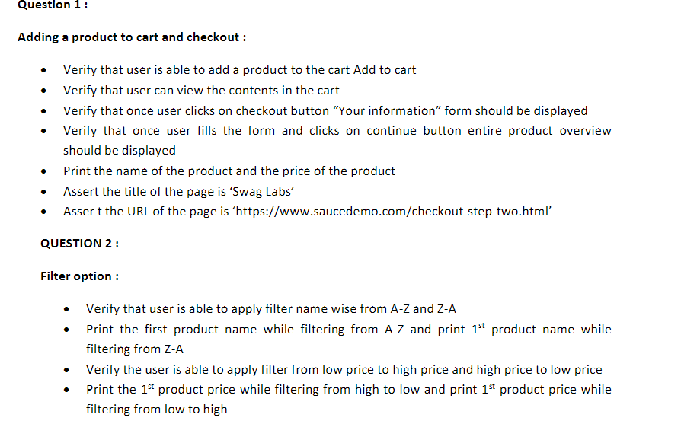

**CODE:**

package q1;

import org.openqa.selenium.By;

import org.openqa.selenium.WebDriver;

import org.openqa.selenium.WebElement;

import org.openqa.selenium.chrome.ChromeDriver;

import org.openqa.selenium.chrome.ChromeOptions;

import io.github.bonigarcia.wdm.WebDriverManager;

public class ques1 {

public static void main(String[] args) throws InterruptedException {

// **TODO** Auto-generated method stub

ChromeOptions co=new ChromeOptions();

co.addArguments("--remote-allow-origins=*");

WebDriverManager.*chromedriver*().setup();

WebDriver driver = new ChromeDriver();

driver.get("https://www.saucedemo.com/");

driver.manage().window().maximize();

WebElement user = driver.findElement(By.*xpath*("/html/body/div/div/div[2]/div[1]/div/div/form/div[1]/input"));

user.sendKeys("standard_user");

WebElement pass = driver.findElement(By.*xpath*("/html/body/div/div/div[2]/div[1]/div/div/form/div[2]/input"));

pass.sendKeys("secret_sauce");

driver.findElement(By.*xpath*("/html/body/div/div/div[2]/div[1]/div/div/form/input")).click();

Thread.*sleep*(3000);

driver.findElement(By.*xpath*("/html/body/div/div/div/div[2]/div/div/div/div[1]/div[2]/div[2]/button")).click();

driver.findElement(By.*xpath*("/html/body/div/div/div/div[1]/div[1]/div[3]/a")).click();

Thread.*sleep*(3000);

String str1=driver.findElement(By.*xpath*("/html/body/div/div/div/div[2]/div/div[1]/div[3]/div[2]/div[2]/button")).getText();

if(str1.equals("Remove")) {

System.***out***.println("Item added to cart");

}

else {

System.***out***.println("Item not added");

}

driver.findElement(By.*xpath*("/html/body/div/div/div/div[1]/div[1]/div[3]/a")).click();

String product = "Sauce Labs Backpack";

if(driver.findElement(By.*xpath*("/html/body/div/div/div/div[2]/div/div[1]/div[3]/div[2]/a/div")).getText().equals(product));

{

System.***out***.println("USER CAN VIEW THE CART");

}

driver.findElement(By.*xpath*("/html/body/div/div/div/div[2]/div/div[2]/button[2]")).click();

if(driver.findElement(By.*xpath*("/html/body/div/div/div/div[1]/div[2]/span")).getText().equals("Checkout: Your Information")) {

System.***out***.println("FORM IS DISPLAYED");

}

Thread.*sleep*(3000);

driver.findElement(By.*xpath*("//*[@id=\"first-name\"]")).sendKeys("savi");

driver.findElement(By.*xpath*("//*[@id=\"last-name\"]")).sendKeys("k");

driver.findElement(By.*xpath*("//*[@id=\"postal-code\"]")).sendKeys("54321");

driver.findElement(By.*xpath*("//*[@id=\"continue\"]")).click();

System.***out***.println("Name of the product: " + driver.findElement(By.*xpath*("/html/body/div/div/div/div[2]/div/div[1]/div[3]/div[2]/a/div")).getText());

System.***out***.println("Price of the product: " + driver.findElement(By.*xpath*("/html/body/div/div/div/div[2]/div/div[1]/div[3]/div[2]/div[2]/div")).getText());

String actualURL=driver.getCurrentUrl();

String expectedURL="https://www.saucedemo.com/checkout-step-two.html";

if(expectedURL.equals(actualURL)) {

System.***out***.println("URL MATCHED");

}

else {

System.***out***.println("URL DID NOT MATCH");

}

String actualTitle=driver.getTitle();

String expectedTitle="Swag Labs";

if(expectedTitle.equals(actualTitle)) {

System.***out***.println("Title Matched");

}

else {

System.***out***.println("Title not Matched");

}

}

}

**OUTPUT:**

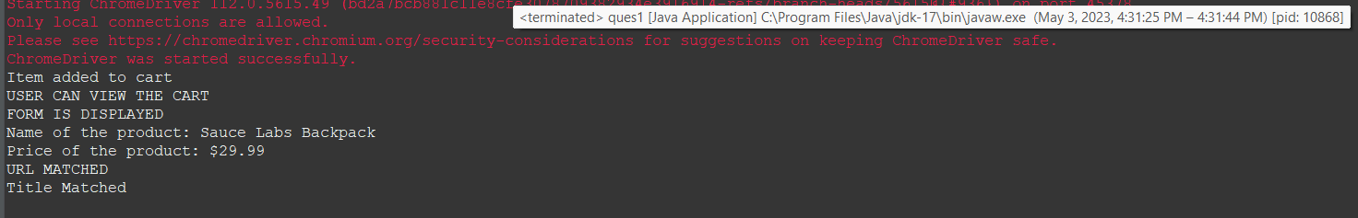

**QUESTION 2**

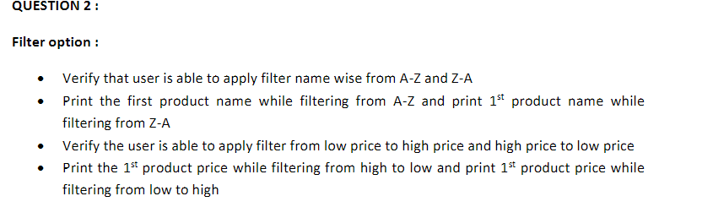

**CODE:**

package q1;

import org.openqa.selenium.By;

import org.openqa.selenium.WebDriver;

import org.openqa.selenium.WebElement;

import org.openqa.selenium.chrome.ChromeDriver;

import org.openqa.selenium.chrome.ChromeOptions;

import io.github.bonigarcia.wdm.WebDriverManager;

public class ques2 {

public static void main(String[] args) throws InterruptedException {

// **TODO** Auto-generated method stub

WebDriverManager.*chromedriver*().setup();

ChromeOptions co=new ChromeOptions();

co.addArguments("--remote-allow-origins=*");

WebDriver driver=new ChromeDriver(co);

driver.get("https://www.saucedemo.com/");

Thread.*sleep*(2000);

driver.manage().window().maximize();

WebElement name=driver.findElement(By.*xpath*("//*[@id=\"user-name\"]"));

name.sendKeys("standard_user");

Thread.*sleep*(2000);

WebElement pwd=driver.findElement(By.*xpath*("//*[@id=\"password\"]"));

pwd.sendKeys("secret_sauce");

Thread.*sleep*(2000);

WebElement btn=driver.findElement(By.*xpath*("//*[@id=\"login-button\"]"));

btn.click();

Thread.*sleep*(2000);

WebElement c1=driver.findElement(By.*xpath*("//*[@id=\"header_container\"]/div[2]/div/span/select"));

c1.click();

Thread.*sleep*(2000);

WebElement c2=driver.findElement(By.*xpath*("//*[@id=\"header_container\"]/div[2]/div/span/select/option[1]"));

c2.click();

Thread.*sleep*(2000);

String e1=driver.findElement(By.*xpath*("//*[@id=\"item_4_title_link\"]/div")).getText();

System.***out***.println("A to Z Order's 1st Product Title: "+e1);

WebElement c3=driver.findElement(By.*xpath*("//*[@id=\"header_container\"]/div[2]/div/span/select/option[2]"));

c3.click();

Thread.*sleep*(2000);

String e2=driver.findElement(By.*xpath*("//*[@id=\"item_3_title_link\"]/div")).getText();

System.***out***.println("Z to A Order's 1st Product Title: "+e2);

Thread.*sleep*(1000);

WebElement c4=driver.findElement(By.*xpath*("//*[@id=\"header_container\"]/div[2]/div/span/select/option[3]"));

c4.click();

Thread.*sleep*(2000);

String e3=driver.findElement(By.*xpath*("//*[@id=\"item_2_title_link\"]/div")).getText();

System.***out***.println("Low to High Order's 1st Product Title: "+e3);

WebElement c5=driver.findElement(By.*xpath*("//*[@id=\"header_container\"]/div[2]/div/span/select/option[4]"));

c5.click();

Thread.*sleep*(2000);

String e4=driver.findElement(By.*xpath*("//*[@id=\"item_5_title_link\"]/div")).getText();

System.***out***.println("High to Low Order's 1st Product Title: "+e4);

Thread.*sleep*(1000);

}

}

**OUTPUT:**

